|  |
| --- |
|  |
| 新概念 3 册 |
| Lesson14 A noble gangster |

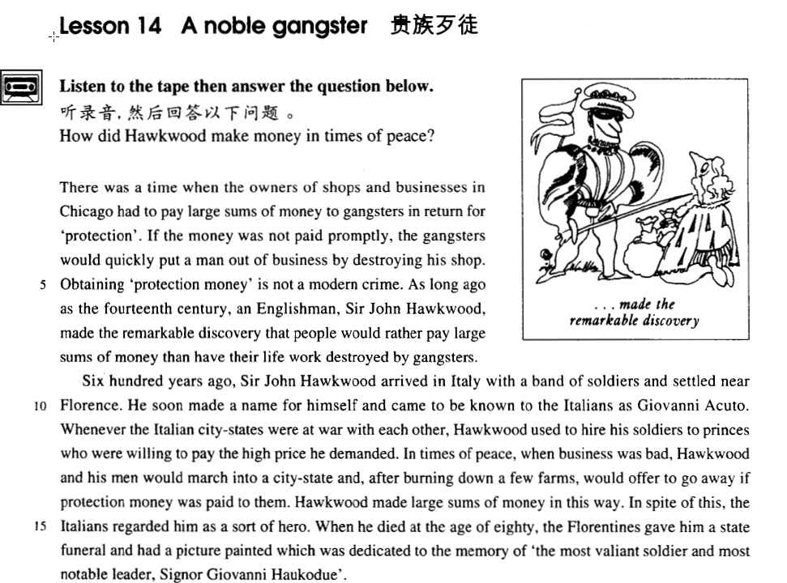

课文

There was a time when the owners of shops and businesses in Chicago had to pay large sums of money to gangsters in return for 'protection'.

曾经有一个时期,芝加哥的店主和商行的老板们不得不拿出大笔的钱给歹徒以换取'保护'。

If the money was not paid promptly, the gangsters would quickly put a man out of business by destroying his shop.

如果交款不及时,歹徒们就会很快捣毁他的商店,让他破产.

Obtaining 'protection money' is not a modern crime.

榨取'保护金'并不是一种现代的罪恶行径.

As long ago as the 14th century, an Englishman, Sir John Hawkwood, made the remarkable discovery that people would rather pay large sums of money than have their life work destroyed by gangsters.

早在14世纪,英国人约翰.霍克伍德就有过非凡的发现:'人们情愿拿出大笔的钱,也不愿毕生的心血毁于歹徒之手.

Six hundred years ago, Sir John Hawkwood arrived in Italy with a band of soldiers and settled near Florence.

600年前,约翰.霍克伍德爵士带着一队士兵来到意大利,在佛罗伦萨附近驻扎下来,

He soon made a name for himself and came to be known to the Italians as Giovanni Acuto.

很快就出了名.意大利人叫他乔凡尼.阿库托.

Whenever the Italian city-states were at war with each other, Hawkwood used to hire his soldiers to princes who were willing to pay the high price he demanded.

每次意大利各城邦之间打伏,霍克伍德把他的士兵雇佣给愿给他出高价的君主。

In times of peace, when business was bad, Hawkwood and his men would march into a city-state, and after burning down a few farms, would offer to go away if protection money was paid to them.

和平时期,当生意萧条时,霍克伍德便带领士兵进入某个城邦,纵火烧毁一两个农场,然后提出,如向他们缴纳保护金,他们便主动撤离。

Hawkwood made large sums of money in this way.

霍克伍德用这种方法挣了大笔钱.

In spite of this, the Italians regarded him as a sort of hero.

尽管如此,意大利人还是把他视作某种英雄。

When he died at the age of 80, the Florentines gave him a state funeral and had a picture painted which was dedicated to the memory of 'the most valiant soldier and most notable leader, Signor Giovanni Haukodue'.

他80岁那年死去时,佛罗伦萨人为他举行了国葬,并为他画像以纪念这位'骁勇无比的战士、杰出的领袖乔凡尼.阿库托先生.'

词汇讲解

* **gangster ['gæŋstə(r)]** n. 歹徒，强盗

**gang *n.*** 群；一伙；一组

* the Gang of Four
* Hi, **gang**. 大家好。 /你们好。
* **对话**
* Hi, **gang**. Hi, everybody. Well, what's going on? Anybody home?

We're in here, Dad.

Oh. **Hi, gang**.

Hello, Philip. How was your day?

My day was just fine. So was my night.

* **promptly** ['prɒmptli] adv. 准时地
* She arrived **promptly** （准时地）at ten.
* She arrived **punctually** （准时地）at ten.
* She arrived at ten **sharp**（准时的，口语）.
* An ambulance was **promptly**（立刻）dispatched to the area.

形容词形式

a **prompt** / **punctual** start

* Staff should be **prompt** in dealing with complaints.
* **六级真题**

The drowning child was saved by Dick’s______D_______action.

A) acute B) alert

C) profound D) prompt

* **remarkable** [rɪ'mɑ:kəbl] adj. 不同寻常的，非凡的

a **remarkable** feat 非凡的功绩

a **remarkable** achievement 非凡的成就

**be remarkable for …** 非凡的

* He is **remarkable** for his memory.

近义词：**extraordinary**

* her **extraordinary** beauty
* Nelson Mandela is a truly **extraordinary** man.

近义词：**exceptional**

* The child had shown **exceptional** courage.
* Her scores are quite **exceptional**.
* **hire** ['haɪə(r)] v. 雇佣，租用；出租

注意介词搭配的不同含义

**hire … from …** 雇佣，租用

**= rent … from …**

**hire (out) … to …** 出租

**= rent (out) … to …**

**A hires / rents (out) B to C C hires / rents B from A**

* **dedicate ['dedɪkeɪt]** v. 奉献；把…（作品）…题献给

**dedicate / devote … to …** 表“奉献”，注意介词搭配 to

* He has **dedicated** himself **to** scientific research. （奉献）
* After he has retired, he will **devote** himself **to** gardening. （奉献）
* **dedicated** **to** （献给）my beloved wife

注意区分：**sacrifice … for …** 为了…而牺牲

**dedicated *adj.*** 专用的；专注的；献身的 (时间和精力都投入)

* A truly **dedicated** bargain hunter must have patience, and above all, the ability to recognize the worth of something when he sees it.
* **memory** ['meməri] n. 纪念（对死者的追忆）

**in memory of …** 追忆某人

**= to the memory of …** 追忆某人

* The monument was built **in memory of** all the soldiers who died in the war.
* The monument was built **to the memory of** all the soldiers who died in the war.

**commemorate *vt.*** 庆祝，纪念；成为…的纪念

* A statue has been built to commemorate the 100th anniversary of the poet’s birthday.

课文讲解

# There was a time when the owners of shops and businesses in Chicago had to pay large sums of money to gangsters in return for 'protection'.

知识点（一）

**there was a time when …** 当年、曾几何时

= **once**

* **There was a time when** I was down and out（穷困潦倒）.

**there are times when …** 有时候…

= **sometimes**

* **There are times when** even the tiger sleeps.
* **There are times when** silence has the loudest voice.
* **There are times when** we would willingly give everything we possess to save our lives, yet we might grudge paying a surgeon a high fee for offering us precisely this service.

**there are rare instances when …** 偶尔…

= **occasionally**

* **There are rare instances when** justice almost ceases to be an abstract concept.
* **造句**：在个别情况下，爱国主义(patriotism)不再是一个空洞的口号(an empty slogan)

There are rare instances when patriotism ceases to be an empty slogan*.

知识点（二） 名词先看可数不可数

* A recent case concerns Jane Butlin whose fiancé, John, runs a successful furniture business （公司，可数）.

… put a man out of business （商业，不可数）…

…, when business（生意，不可数） was bad, …

He has done a lot of business （生意，不可数） here in Beijing.

知识点（三）

pay large sums of money 付大笔的钱

make large sums of money 赚大笔的钱

earn enormous sums of money 赚海量的的钱

* He earned **enormous**（巨大的，海量的） sums of money …

知识点（四） 介词in表示目的

**in return for …** 作为报答，以换取、以报答

* America helped the rebels **in return for** their promise to support democracy.
* He is always willing to help people out, without expecting anything **in return**（作为报答）.

**in exchange for …** 以换取

* They were given food and shelter **in exchange for** work.

**in compensation for …** 以补偿

* She received $10,000 **in compensation for** her injuries at work.

**in memory of （死者）…** 以追忆死者

**in honor of …** 以尊敬

* The college was named **in honor of** George Washington.
* a banquet **in honor of** the president.

**in appreciation of …** 以感激

* I sent him a gift **in appreciation of** his help.

**in recognition of …** 以表彰

* He was awarded one of the ‘Ten Outstanding Young Persons’ **in recognition of** his significant achievements.

# If the money was not paid promptly, the gangsters would quickly put a man out of business by destroying his shop.

知识点（一）

the money

表示**：protection money** 保护费

知识点（二）

**put sb. out of business** 使某人破产

= **make sb. broke / bankrupt\***

**put sb.** **out of work** 使某人失业

**out of**

* The changing economic conditions have put many people **out of** work.
* I am **out of** patience.
* I am **out of** anger.
* The TV is **out of** repair.

# Obtaining 'protection money' is not a modern crime.

知识点（一）

obtaining 当前课文上下文表示“勒索”

**extort sth**. 勒索某物

* Gangsters used to **extort money** from local businessmen.

**blackmail sb.** 敲诈某人

* Someone was trying to **blackmail him** with pictures of him and his mistress.

# As long ago as the fourteenth century, an Englishman, *Sir John Hawkwood*, made the remarkable discovery that people would rather pay large sums of money than have their life work destroyed by gangsters.

知识点（一）

**as long ago as …** 早在……就……

**= as early as …**

* **造句**：早在公元前十五世纪，这座庙宇就被当作做礼拜的场所。

**As long ago as** the 15th century BC, the temple was used as a place of worship.

知识点（二）

**Sir +名字** 爵士

* Sir Winston Churchill
* Sir Winston
* Mr. Churchill 先生

知识点（三）

**短语用法复习：宁愿…而不愿…**

**would rather / sooner do than do** （两个东西都不好，第一个还稍微强一点）

**prefer to do rather than do** （两个东西都不错，第一个更好一些）

**prefer doing to doing** （两个东西都不错，第一个更好一些）

* **课后习题讲解：**

5． People prefer paying large sums of money ___C___ their life work destroyed by gangsters. (11.7-8)

(a) than have (b) to have (c) to having (d) than they have

知识点（三） 语法复习：虚拟语气

**would rather / sooner (that) … 虚拟语气**

* I’d rather (that) Susan were here now.

知识点（四）

**have sth. done** 某人不愉快的经历

* He had his watch stolen.
* King Charles І had his head cut off.

# Six hundred years ago, Sir John Hawkwood arrived in Italy with a band of soldiers and settled near Florence.

* **造句**：早在 1984 年，我就随父母到了北京，并在天坛 (the Temple of Heaven)附近定居了下来。
* **As long ago as** 1984, I arrived in Beijing with my parents and settled near the Temple of Heaven.

知识点（一）

**settle down** 安顿下来、安静下来

* They'd like to see their daughter **settle down**, get married, and have kids.
* Assuming that his family had been killed during an air raid, Hans **settled down** in a village fifty miles away where he had remained ever since.

# He soon made a name for himself and came to be known to the Italians as Giovanni Acuto.

知识点（一）成名、出名

**make a name for oneself** 成名、出名

* Ge You first **made a name for himself** in the movie ‘Wan Zhu’.

**become famous overnight** 迅速成名

* With the success of their first record, **they became famous overnight.**

**rise to fame** 成名、出名

* Mendoza rose to fame swiftly* after a boxing match when he was only fourteen years old.

**make (the) headlines** （事情）出名

**hit the headlines** （事情）出名

* The 9/11 terrorist attack **made (the) headlines** around the world.
* The 9/11 terrorist attack **hit the headlines** around the world.

知识点（二）成名、出名

**A be known to B as …** B 把 A 称为…

* He was known to us all as Dickie and his eccentricity had become legendary long before he died.
* **造句**：中国人把李白称为诗仙 (poet immortal)。
* Li Bai is known to the Chinese as ‘poet-immortal’.
* 造句：篮球运动员 Earvin Johnson 迅速出名了，并且美国人开始把他称为“魔术师约翰逊”。
* Basketball player Earvin Johnson soon made a name for himself and came to be known to the Americans as ‘Magic Johnson’.

# *Whenever the Italian city-states were at war with each other*, Hawkwood used to hire his soldiers to princes who were willing to pay the high price he demanded.

知识点（一）

**be at war with …** 与…处于战争状态

* China had **been at war with** Japan for 8 years.

**declare war on …** 向…宣战

* The Chinese government has **declared war on** official corruption.

**wage war on …** 发动战争

* We continually **wage war on** them, for they contaminate* our food, carry diseases, or devour our crops.
* **课后习题讲解：**

6 Princes used to hire ____B___ Hawkwood. (11.1 1-12)

1. his soldiers from (b) soldiers from (c) soldiers of (d) some soldiers of

# In times of peace, when business was bad, Hawkwood and his men would march into a city-state and, *after burning down a few farms*, would offer to go away if protection money was paid to them.

知识点（一）

Business is bad / slow / slack*. 生意不好

Business is good / booming. 生意好

The general commanded **his men**(手下) to fire.

subordinate ***n.*** 下属，下级；部属，属下

* **造句**：早在 20 世纪 30 年代，红军就完成了伟大的长征，在这期间他们走过了 25,000 里。
* As long ago as the 1930’s, the Red Army had completed the successful Long March during which they covered 25,000 li.
* A week before, he had completed a successful overland flight **during which** (在此期间) he covered twenty-six miles.

知识点（二）

**offer to do …** 主动提出做某事

= **volunteer to do …**

* Jill **volunteered to go** with me to the hospital.

知识点（三） 短语复习：只要…就…/只有…才…

**provided (that) …** 只要…就…

**providing (that) …** 只要…就…

**as / so long as …** 只要…就…

**on condition (that)** 只要…就… ；注意condition前没有冠词

* 'So long as there's something to identify, we will give people their money back,' said a spokeswoman for the Bank.

**… only if …** 只有…才…

* She will go only if Peter goes.
* Only if Peter goes *will* she go. (语法复习：倒装)

# Hawkwood made large sums of money in this way.

# In spite of this, the Italians regarded him as a sort of hero.

a sort of hero 这里要翻译成“英雄般的”

# When he died at the age of eighty, the Florentines gave him a state funeral and had a picture painted which was dedicated to the memory of 'the most valiant soldier and most notable leader, Signor Giovanni Haukodue'.

Only the good die young. 好人不长命

the Florentines gave him a state funeral

= …, the Florentines held a state funeral for him.

a state funeral 国葬

a state visit 国事访问

a state banquet 国宴

state affairs 国家大事

the State Council 国务院

* **造句**：当罗纳德·里根在 93 岁去世时，美国人为他举行了一次国葬，并请人塑了一尊塑像以纪念这位伟大的总统。
* When Ronald Reagan died at the age of 93, the Americans gave him a state funeral and had a statue built which was dedicated to the memory of the great president.

# 总结

**高级作文句子要领**

**1、复合句为主，简单句作为点缀和过渡。**

**2、句式多变，尤其句首切忌雷同。**

**第一段：**

**①** 无灵主语开头，复合句。

* There was a time when the owners of shops and businesses in Chicago had to pay large sums of money to gangsters in return for 'protection'.

**②** 条件状语从句开头，复合句。

* If the money was not paid promptly, the gangsters would quickly put a man out of business by destroying his shop.

**③** 无灵主语开头，简单句。

* Obtaining 'protection money' is not a modern crime.

**④** 介词短语作时间状语开头，复合句。

* As long ago as the 14th century, an Englishman, Sir John Hawkwood, made the remarkable discovery that people would rather pay large sums of money than have their life work destroyed by gangsters.

**第二段：**

**①** 副词短语作时间状语开头，复合句。

* Six hundred years ago, Sir John Hawkwood arrived in Italy with a band of soldiers and settled near Florence.

**②** 主谓结构开头，复合句。

* He soon made a name for himself and came to be known to the Italians as Giovanni Acuto.

**③** 让步状语从句开头，复合句。

* Whenever the Italian city-states were at war with each other, Hawkwood used to hire his soldiers to princes who were willing to pay the high price he demanded.

**④** 介词短语作时间状语开头，复合句。

* In times of peace, when business was bad, Hawkwood and his men would march into a city-state and, after burning down a few farms, would offer to go away if protection money was paid to them.

**⑤** 主谓结构开头，简单句。

* Hawkwood made large sums of money in this way.

**⑥** 介词短语作让步状语开头，简单句。

* In spite of this, the Italians regarded him as a sort of hero.

**⑦** 时间状语从句开头，复合句。

* When he died at the age of 80, the Florentines gave him a state funeral and had a picture painted which was dedicated to the memory of 'the most valiant soldier and most notable leader, Signor Giovanni Haukodue'.

**Sentence opening is very important to create sentence variety.**

句子开头对制造句子的多样性是至关重要的。